STAR Methods

Instructions:
https://www.cell.com/pb-assets/journals/research/cell/methods/Methods_Guide_general-1724873926937.pdf

We need to include the following 4 sections:
- Experimental model and study participant details
- Method details
- Quantification and statistical analysis
- Additional resources

Example genomics papers:
- https://www.cell.com/current-biology/fulltext/S0960-9822(24)00144-1
- https://www.cell.com/current-biology/fulltext/S0960-9822(23)00186-0
- https://www.cell.com/current-biology/fulltext/S0960-9822(18)31609-9
- https://www.cell.com/current-biology/fulltext/S0960-9822(24)01284-3

EXPERIMENTAL MODEL AND STUDY PARTICIPANT DETAILS

This study involves sequencing and assembling genomes from 8 Blaberidae species, analysed with 15 previously generated Blattodea and 77 Blattabacterium genomes (Table S1). Specimens of Macropanesthia lithgowae, Neogeoscapheus dahmsi, Panesthia lata, Panesthia sloanei, Panesthia tryoni tegminifera, Panesthia tryoni tryoni (Eungella), Panesthia tryoni tryoni (Kroombit Tops) and Parapanesthia gigantea were collected throughout Australia. Leg muscle and fat body tissue were used for DNA extractions (see ‘Method Details).

METHOD DETAILS

DNA extraction, library and sequencing details
Genomic DNA was prepared from the leg muscle tissue of M. lithgowae P. tryoni tryoni (Kroombit), P. sloanei, and P. lata, while the DNA of Par. gigantea, P. tryoni tegminifera, P. tryoni tryoni (Eungella) and N. dahmsi was extracted from both leg muscle and fat body tissue. Live cockroaches were chilled at –30 °C for 4–5 min to induce torpor, and the femoral muscle (~3 mm) was dissected from one or two hind legs, depending on body size. Tissue was incubated overnight at 56 °C in 600 µl SDS buffer with 20 µl Proteinase K, followed by RNase A treatment (5 µl, 37 °C, 1 h). DNA extractions were performed using the phenol chloroform method, or using the NEB Monarch HMW DNA Extraction Kit (NEB #T3060). The phenol chloroform method involved purifying DNA by phenol chloroform extraction and isopropanol precipitation with sodium acetate (3 M, pH 5.5), washing twice with 70% ethanol, air-drying, and dissolving in 40 µl 10 mM Tris (pH 8.0). The NEB Monarch HMW DNA Extraction Kit was used according to the manufacturer’s instructions, with the exception that Proteinase K digestion was undertaken for 4 hours at 600 rpm, rather than the recommended 45 minutes, to ensure thorough digestion of the tissue. As minimal gDNA appeared to stick to the glass beads, the supernatant was centrifuged for 10 minutes at 16,000 g at room temperature, the pellet was washed twice in 500 uL kit Wash Buffer, dried briefly then resuspended in 20 uL Elution Buffer II. The quality and integrity of the gDNA was assessed by a 4200 TapeStation System (Agilent Technologies) using Genomic DNA ScreenTape (Cat No. 5067-5365) and reagents (Cat No. 5067-5366). The absorbance ratios were assessed by Nanodrop Spectrophotometer (DeNovix DS-11). Concentration was determined using a Qubit 2.0 Fluorometer (Invitrogen by Life Technologies) using a dsDNA BR assay kit (Cat No. Q32850).

Long-read sequencing was performed using gDNA from M. lithgowae, N. dahmsi, P. lata, P. sloanei, P. tryoni tryoni, P. tryoni tegminifera and Par. gigantea (Table S1). Libraries were prepared from gDNA using the Ligation Sequencing Kit V14 (SQK-LSK114) protocol according to the manufacturer’s instructions with the following modifications and options. The DNA Repair and End-Prep reaction continued for 15-20 minutes. The Adapter ligation reaction proceeded for 20 minutes and the kit LFB wash buffer was used to enrich for longer fragments. Final library elution occurred at 37ºC to improve the recovery of long fragments. The integrity and concentration of final libraries were assessed using a 4200 TapeStation System (Agilent Technologies) and Qubit 2.0 Fluorometer (Invitrogen by Life Technologies) as previously described.

Libraries were sequenced on a PromethION 24 sequencer (Oxford Nanopore Technologies) using R10.4.1 flow cells (FLO-PRO114M), following the manufacturer’s instructions. Libraries were stored at 4ºC for less than a week if not sequenced immediately. The sequencing output was additionally increased by washing the flow cells (EXP-WSH004) after approximately 24 and 48 hours, and reloading the libraries for sequencing for a total of 72 hours. Sequencing was performed in super-accurate base-calling v4.3.0 mode (400 bps) and parameters set to also capture methylation 5mC + 5hmC modified bases.

Genome assembly and annotation

For the ONT sequencing that incorporated duplex base calling (Table S1), redundant simplex reads (i.e. simplex reads which have duplex offsprings) were removed using samtools v1.2 (Danecek et al., 2021). Adapters were trimmed for all ONT sequence data (with and without duplex calling) and converted into fastq files using dorado v0.6 (https://github.com/nanoporetech/dorado).

A de novo assembly was carried out using the trimmed ONT data using Flye v 2.9.3 (Kolmogorov et al., 2019). After some initial optimisation experiments, the ONT sequencing data with duplex calling was assembled using the ‘ONT corrected’ mode (--nano-corr) and a minimum overlap of 10,000 (--min-overlap 10000), while the other ONT sequencing data was assembled using the ‘ONT raw’ mode (--nano-raw) and default settings. An additional two iterations of polishing were carried out after the assemblies. The purge_dups v1.2.5 (Guan et al., 2020) pipeline was used to remove putative haplotypic duplications and heterozygous overlaps from the genomes. Raw ONT reads were mapped to the draft assembly using minimap2 v2.18 (Li, 2018) for this purging step. QUAST v# (Gurevich et al., 2013) was used to assess the assembly continuity, and BUSCO v# was used to assess assembly completeness (utilizing the Insecta lineage data set; Simão et al., 2015; Waterhouse et al., 2019).

The genome assemblies were annotated using FGENESH++ v7.2.2 (Salamov & Solovyev, 2000; Solovyev et al., 2006), performed on the Nimbus cloud service provided by the Pawsey Supercomputing Centre. Prior to annotation, we generated a repeat library with RepeatModeler v2.0.1 (Flynn et al., 2020) and masked repetitive elements in the assemblies using RepeatMasker v4.0.6 (Smit et al., 2015), applying the ‘-nolow’ option to exclude low-complexity or simple repeats from masking. The masked and unmasked assemblies were used as input for FGENESH++. Following Ewart et al. (2024), FGENESH++ was run with the non-mammalian general pipeline settings, employing optimized gene-finding parameters trained on the pea aphid (Acyrthosiphon pisum) genome, and a curated insect protein database (provided by Softberry; 2020 release) for “prot_map” homology-based predictions. Ab initio predictions lacking BLAST support were excluded.

These newly assembled genomes were combined with other cockroach and termite genomes from InsectBase 2.0 (Mei et al., 2022), NCBI and Ewart et al. (2024) for subsequent analyses (see Table S1 for species/genome details). Periplaneta americana, Blattella germanica, and Zootermopsis nevadensis had multiple available genomes from various sources, which were all included to assess whether differences in data type and/or assembly methods affected the results in subsequent analyses.

QUANTIFICATION AND STATISTICAL ANALYSIS

Characterising HGT inserts

The following steps were carried out to identify, filter, and age Blattabacterium cuenoti (hereafter Blattabacterium) inserts in the cockroach and termite genomes. This pipeline workflow and the relevant scripts are available on GitHub (link), and outlined in Figure S1. Additionally, alternative thresholds for many of the steps were applied, and are included in brackets below (see the ‘HGT insert QC’ section). The corresponding results when applying these alternative thresholds are presented in the ‘HGT insert QC’ section.
We first created a library comprising 77 Blattabacterium genomes (see Table S1 for genome details), each of which were broken into 150 bp fragments (alternate threshold = 100 bp) using a custom AWK script. These Blattabacterium ‘fragments’ were aligned to the reference host genome using bwa mem v0.7.17 (Li & Durbin, 2009), implementing default parameters. The resultant alignment was converted into a bam file with samtools, then into a bed file using bedtools v2.3 (Quinlan and Hall, 2010). Regions of the cockroach genome against which Blattabacterium fragments aligned with were identified as potential horizontal inserts. In the case that aligned Blattabacterium fragments overlapped on a host contig, or aligned fragments were found within 150 bp of each other on a host contig (alternate threshold = 50 bp), we merged the host region aligning to these sequences as a single putative HGT insert. Putative inserts shorter than 50 bp (alternate threshold = 30 bp) were removed using AWK. Note that inserts were detected in genomes of species for which only leg muscle tissue was included during DNA extraction (thus excluding Blattabacterium), and also species for which fat body was included (thus including Blattabacterium cells and potentially genomic contigs).

Several filtering steps were carried out to remove potential artefactual HGT inserts. First, we conservatively removed any contigs in which genuine Blattabacterium sequences may have been combined with cockroach sequences during genome assembly (and therefore erroneously characterized as HGT inserts). Any contigs for which the total length of putative bacterial sequences (identified using the method above) was ≥ 20% of the total contig length were removed. In addition, we conservatively removed any contigs with one or more contiguous putative HGT inserts above 10,000 bp in length (which were found to be significant outliers based on the length distributions of all putative inserts in our dataset; see Fig. 1B). Second, inserts that formed part of false assembly duplications were identified and removed. To identify these potential false duplicate inserts, the insert regions were extracted from the genomes with 300 bp of flanking sequence (to either side) using bedtools, then BLASTed against all of the other inserts (with flanks) within the same genome using blastn v2.2.3. Inserts were considered false duplicates and removed if the resultant sequence identity was >90% (alternative threshold >95%), and query coverage was >90% (alternative threshold >95%). Third, highly repetitive low-complexity (“low-entropy”) sequences were identified using the symmetrical DUST algorithm (Morgulis et al., 2006) implemented in Minimap2 v.2.28 (Li, 2018, 2021), and any inserts with contiguous, low-entropy regions representing ≥ 50% of the total insert length were removed. Fourth, to ensure that we could characterise the cockroach genomic sequence surrounding each insert, we excluded inserts where either of the 300 bp flanks consisted of >= 50% ambiguous (N) nucleotides. Lastly, inserts that were more similar to other bacteria species (i.e. not Blattabacterium) were removed, as they could be potential artefacts, or genuine inserts of other related Bacteriodales. Each insert was BLASTed against two custom databases: one comprising only Blattabacterum sequences database (n = 77; Table S1), and one with other bacteria, with Blattabacterium sequences removed (n = 2,009,606). If the sequence similarity of the bacteria database BLAST was >2% higher than the Blattabacterium database BLAST, then the sequence was removed. The threshold of 2% was chosen based on preliminary assessment of pairwise genetic divergence between Blattabacterium and close relative Bacteriodales.

Some of the inserts present in a host genome may be the result of a duplication or transposition of a previously insert Blattabacterium sequenced. To identify the number of unique HGT inserts within a genome (i.e. to only count those located in unique genomic regions within the cockroach genomes), we applied a similar approach to that used for the false duplication filter above: inserts were extracted with 300 bp of flanking sequence, then BLASTed against all of the other inserts (with flanking) within the same genome. HGT inserts with a sequence identity >70% (alternative threshold >55%), and query coverage >70% (alternative threshold >55%) were considered duplicated. Finally, manual auditing of the results was performed by additional BLASTs and manual inspections of the sequences themselves. We were particularly stringent when manually curating the termite putative inserts given the existence of termite gut symbionts that are closely related to Blattabacterium (e.g. Bacteroides/Flavobacteria).
The genomic features in which the filtered inserts are located (such as intergenic regions, exons, introns, promoters) were identified by comparing the positions of the inserts and genomic features using bedtools and custom AWK scripts. Genomic annotation files were those previous prepared using FGENESH++.
The minimum age of ancestral inserts across the phylogeny was estimated by comparing sequence similarity of each insert and inserts in other cockroach species against the sequence similarity of each insert and the genome of the host’s specific Blattabacterium strain. For species whose genomes have been sequenced multiple times by different research groups (i.e. Periplaneta americana, Blattella germanica, and Zootermopsis nevadensis), only the genome version with the most inserts was analyzed. Further, inserts part of a duplication/transposition event, as characterised above, were excluded in this dating analysis. To identify putatively ancestral inserts, the filtered inserts were first extracted from the genomes using bedtools. Second, each insert from a given cockroach genome was BLASTed against the specific Blattabacterium strain that the species harbours (Table S1). Only species with a published species-specific Blattabacterium strain were included (n = 11). Third, each insert was BLASTed against all of the inserts from the other cockroach/termite taxa (excluding itself). Fourth, the two BLAST output files were compared using a custom R script. The hit was set to ‘NA’ and query coverage was <70%.
If sequence identity was considerably higher for the Blattabacterium BLAST compared to BLASTs of inserts from other cockroach/termite genomes, then the insertion was considered to have occurred subsequent to the host’s divergence from the other species in the sample. In contrast, if sequence identity was higher for one or more inserts from the termite/cockroach library, than for the host’s Blattabacterium, then the insert was considered ancestral to those species sharing it. Lastly, if sequence identities for the two BLAST hits were somewhat similar, we were unable to classify the age of the insert with confidence. Clear separations between these three cases were evident in each of the analyses (see Fig. 2A). Putatively ancestral inserts were manually curated by aligning them back to the genomes from which they derived and checking for sequence synteny (see example in Fig. 2B). The divergence date of the most distantly related species both harbouring the insert was treated as the minimum age of the insert.

We characterised the distribution of origin of the inserts along the Blattabacterium genome. First, we aligned the inserts back to the Blattabacterium genomes using bwa mem. Only species with a published species-specific Blattabacterium strain were included in this analysis (Table S1). Note, not all of the inserts aligned, as some inserts were characterised based on fragments of other Blattabacterium genomes (not only the species-specific Blattabacterium strain). Second, we used a combination of samtools and awk to only retain primary alignments, and to record the insert start position along the alignment. Lastly, we plotted the cumulative start position counts along the Blattabacterium genome using R packages tidyverse v2 (Wickham et al., 2019) and ggplot2 v3.5.1 (Wickham, 2016), whereby a linear trend indicates that the origin of the inserts in the Blattabacterium genome is random.
HGT insert QC
To robustly confirm that inserts were evident in raw genomic reads as well as the final assemblies, we aligned the raw reads against the respective assembled genomes. Raw reads which aligned only with the putative insert, or a subset thereof, were assessed to have likely derived from contaminant Blattabacterium DNA. In contrast, raw reads spanning all or some of the insert as well as ‘native’ cockroach flanking sequence were considered evidence that the insert was genuine. This step was undertaken on five genomes. We found that none of the identified inserts aligned with solely contaminant Blattabacterium reads; rather, each aligned with multiple raw reads spanning the boundary between exogenous inserted DNA and cockroach flanking sequence. In addition, in cases where Blattabacterium contaminant DNA was found to align to the insert (alongside genuine cockroach genomic reads), the Blattabacterium sequences were consistently divergent from the insert sequences (mean pairwise divergence = X%).

To assess the sensitivity of HGT insert counts to our choice of parameters, we re-characterised inserts using alternative, less stringent thresholds (see the ‘Characterising HGT inserts’ section). This led to a greater number of inserts being identified (246-5841 in the cockroach genomes), though overall patterns remained similar (Figure S2). Note that the inserts characterised in the termite genomes using these thresholds were not manually audited, whereas the primary, more stringent dataset underwent particularly rigorous manual curation (given the presence of termite gut symbionts closely related to Blattabacterium).

STAR methods references

Ewart, K. M., Ho, S. Y. W., Chowdhury, A.-A., Jaya, F. R., Kinjo, Y., Bennett, J., Bourguignon, T., Rose, H. A., & Lo, N. (2024). Pervasive relaxed selection in termite genomes. Proceedings of the Royal Society B: Biological Science, 291, 20232439.

Danecek, P., Bonfield, J. K., Liddle, J., Marshall, J., Ohan, V., Pollard, M. O., ... & Li, H. (2021). Twelve years of SAMtools and BCFtools. Gigascience, 10(2), giab008.

Kolmogorov, M., Yuan, J., Lin, Y., & Pevzner, P. A. (2019). Assembly of long, error-prone reads using repeat graphs. Nature biotechnology, 37(5), 540-546.

Guan, D., McCarthy, S. A., Wood, J., Howe, K., Wang, Y., & Durbin, R. (2020). Identifying and removing haplotypic duplication in primary genome assemblies. Bioinformatics, 36(9), 2896-2898.

Li, H. (2018). Minimap2: pairwise alignment for nucleotide sequences. Bioinformatics, 34(18), 3094-3100.

Mei, Y., Jing, D., Tang, S., Chen, X., Chen, H., Duanmu, H., ... & Li, F. (2022). InsectBase 2.0: a comprehensive gene resource for insects. Nucleic acids research, 50(D1), D1040-D1045.

Li, H., & Durbin, R. (2009). Fast and accurate short read alignment with Burrows–Wheeler transform. bioinformatics, 25(14), 1754-1760.

Quinlan, A. R., & Hall, I. M. (2010). BEDTools: a flexible suite of utilities for comparing genomic features. Bioinformatics, 26(6), 841-842.

Salamov, A. A., & Solovyev, V. V. (2000). Ab initio gene finding in Drosophila genomic DNA. Genome research, 10(4), 516-522.

Solovyev, V., Kosarev, P., Seledsov, I., & Vorobyev, D. (2006). Automatic annotation of eukaryotic genes, pseudogenes and promoters. Genome biology, 7, 1-12.

Smit, A., Hubley, R., & Green P. (2015). RepeatMasker Open-4.0. Retrieved from http://www.repeatmasker.org.

Flynn, J. M., Hubley, R., Goubert, C., Rosen, J., Clark, A. G., Feschotte, C., & Smit, A. F. (2020). RepeatModeler2 for automated genomic discovery of transposable element families. Proceedings of the National Academy of Sciences, 117(17), 9451-9457.

Gurevich, A., Saveliev, V., Vyahhi, N., & Tesler, G. (2013). QUAST: quality assessment tool for genome assemblies. Bioinformatics, 29(8), 1072-1075.

Simão, F. A., Waterhouse, R. M., Ioannidis, P., Kriventseva, E. V., & Zdobnov, E. M. (2015). BUSCO: assessing genome assembly and annotation completeness with single-copy orthologs. Bioinformatics, 31(19), 3210-3212.

Waterhouse, R. M., Seppey, M., Simão, F. A., & Zdobnov E. M. (2019). Using BUSCO to assess insect genomic resources. In Insect genomics: methods in molecular biology, vol. 1858 (eds Brown S, Pfrender M). New York, NY: Humana Press.

Wickham, H., Averick, M., Bryan, J., Chang, W., McGowan, L. D., François, R., Grolemund, G., Hayes, A., Henry, L., Hester, J., Kuhn, M., Pedersen, T. L., Miller, E., Bache, S. M., Müller, K., Ooms, J., Robinson, D., Seidel, D. P., Spinu, V., Takahashi, K., Vaughan, D., Wilke, C., Woo, K., & Yutani, H. (2019). Welcome to the tidyverse. Journal of Open Source Software, 4(43), 1686.

Wickham, H. (2016). ggplot2: Elegant Graphics for Data Analysis. Springer-Verlag New York, 2016.

Supplemental Information - Tables and Figures
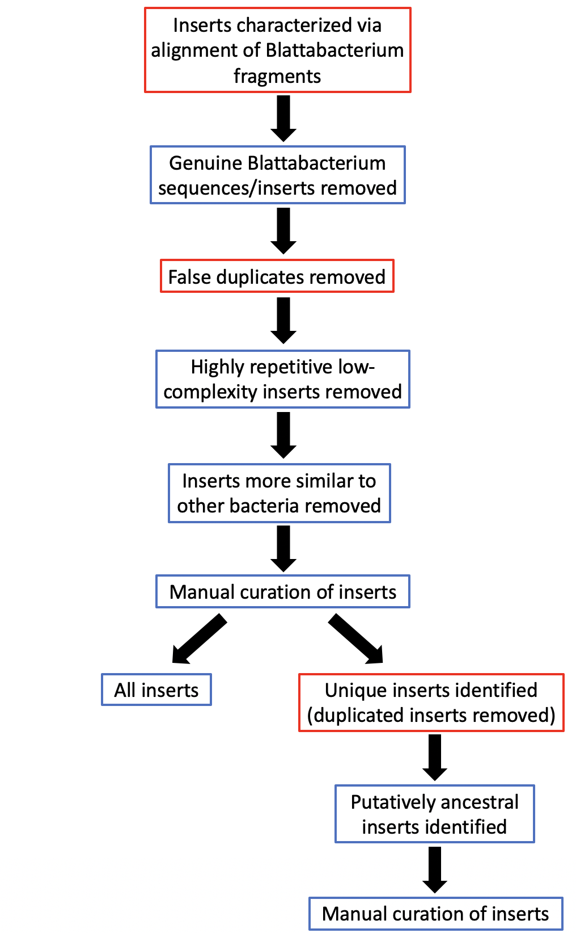
Figure S1. Insert filtering pipeline. The steps outlined with a red border indicate where alternate filtering thresholds were applied, thereby resulting in two set of inserts (with standard and alternate filtering threshold applied; the manual curation steps were not performed for alternate filtering).
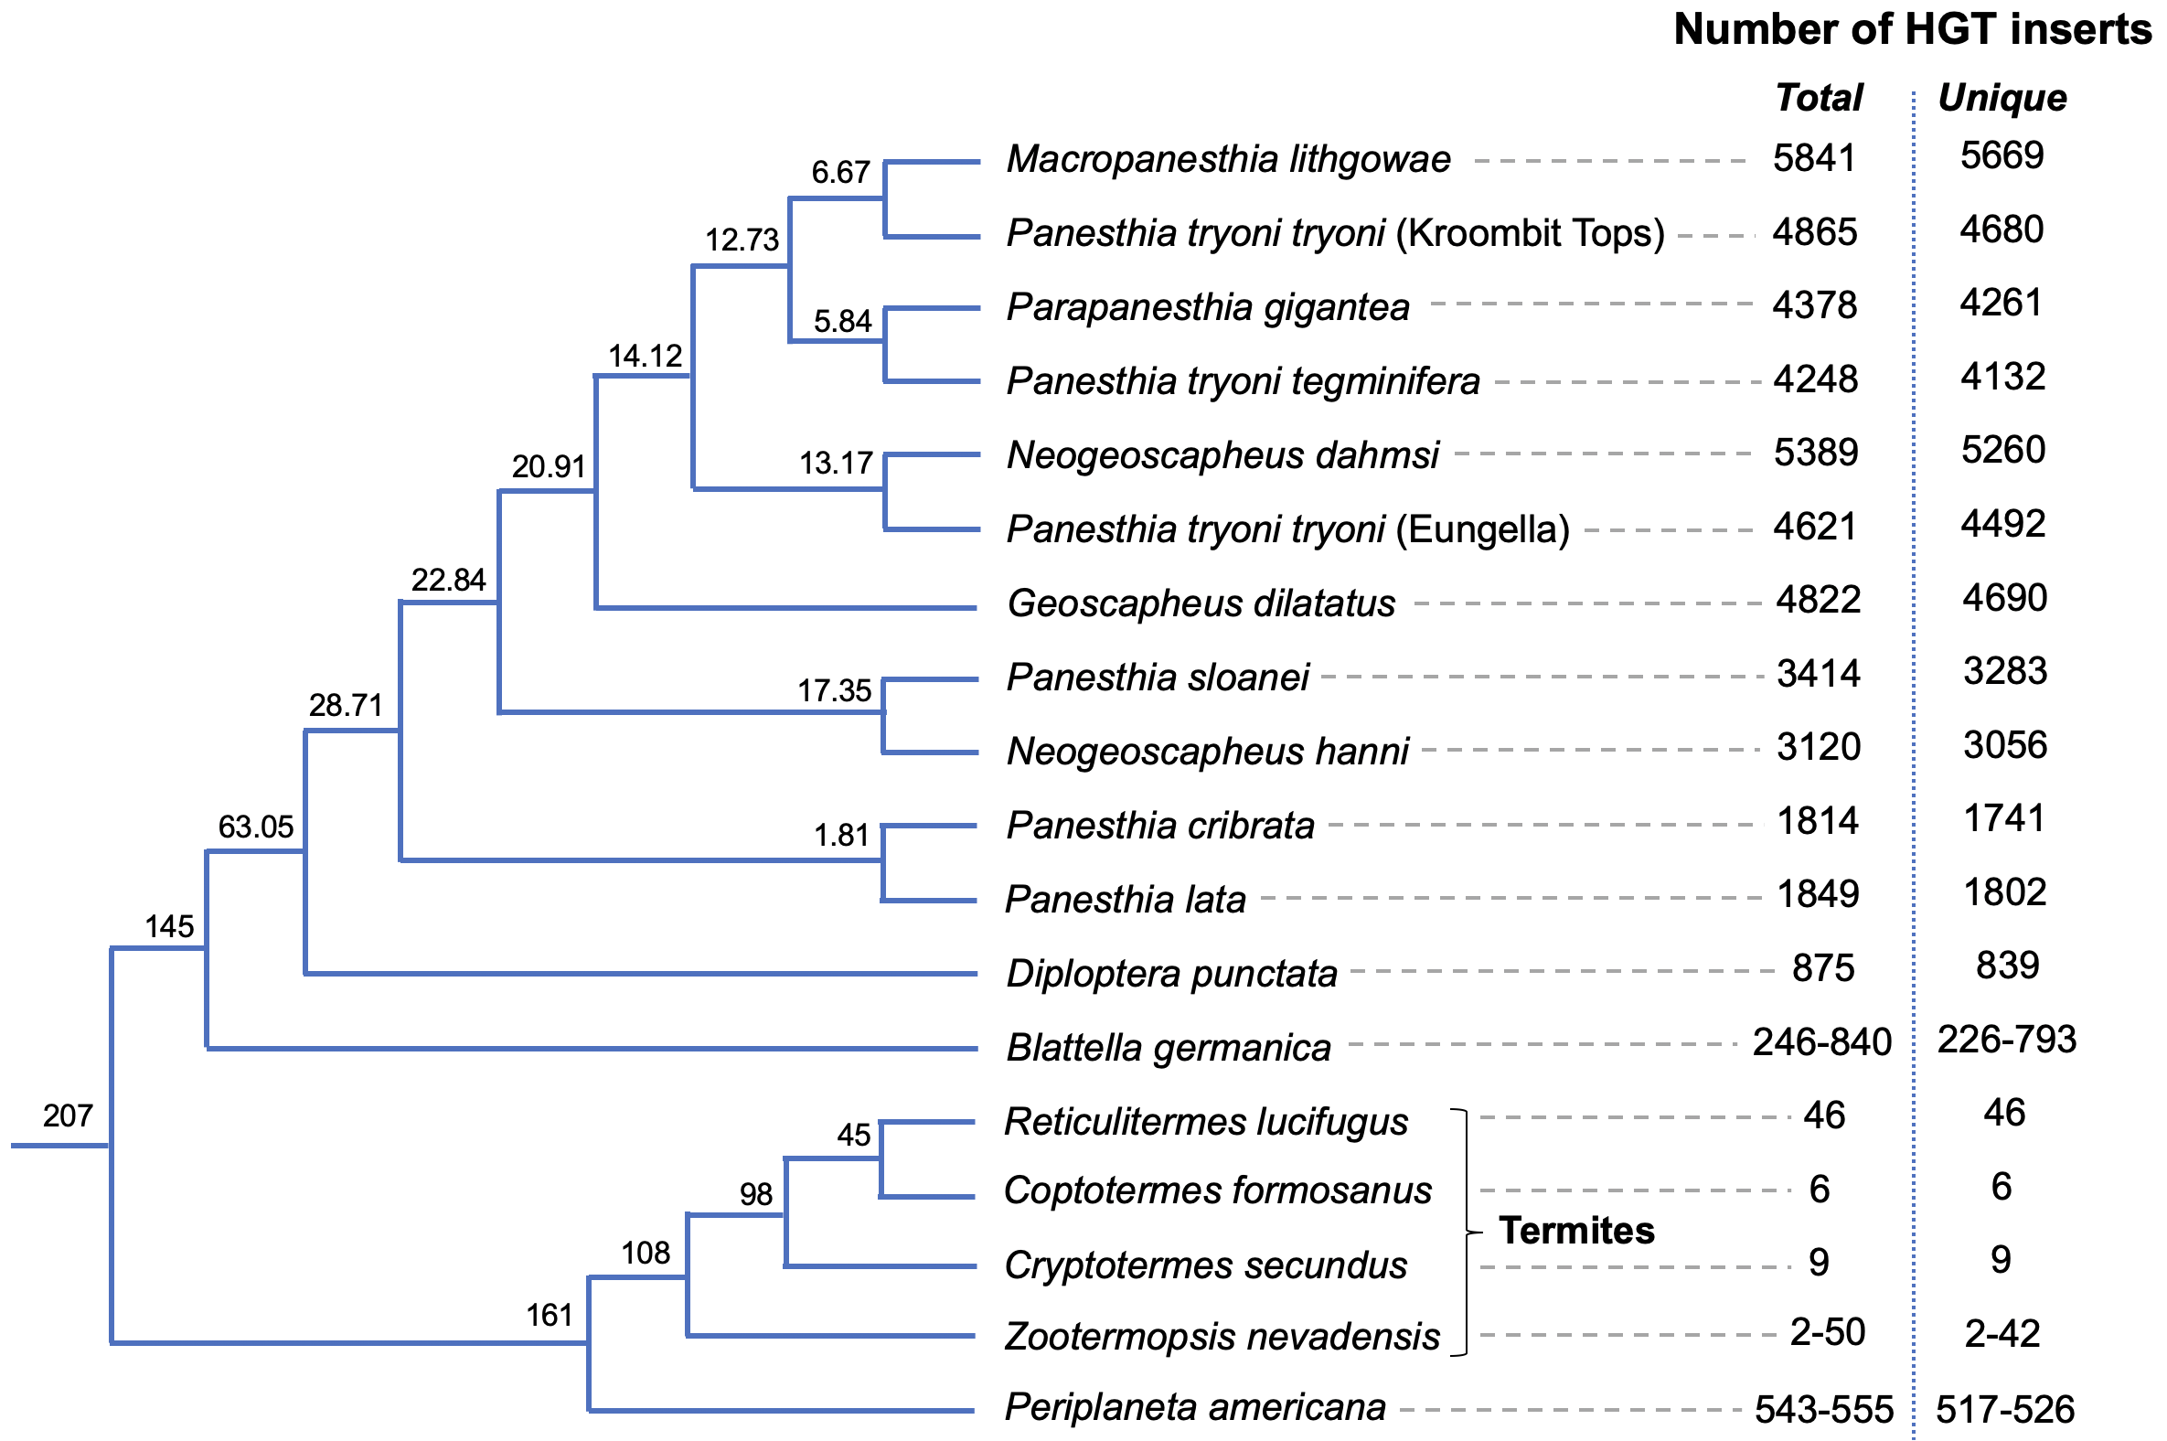
Figure S2. Cladogram of taxa analysed in this study alongside the total number of HGT inserts within each genome, and the number of unique inserts (after excluding inserts likely arising from duplication or transposition) based on the alternative, less stringent thresholds.

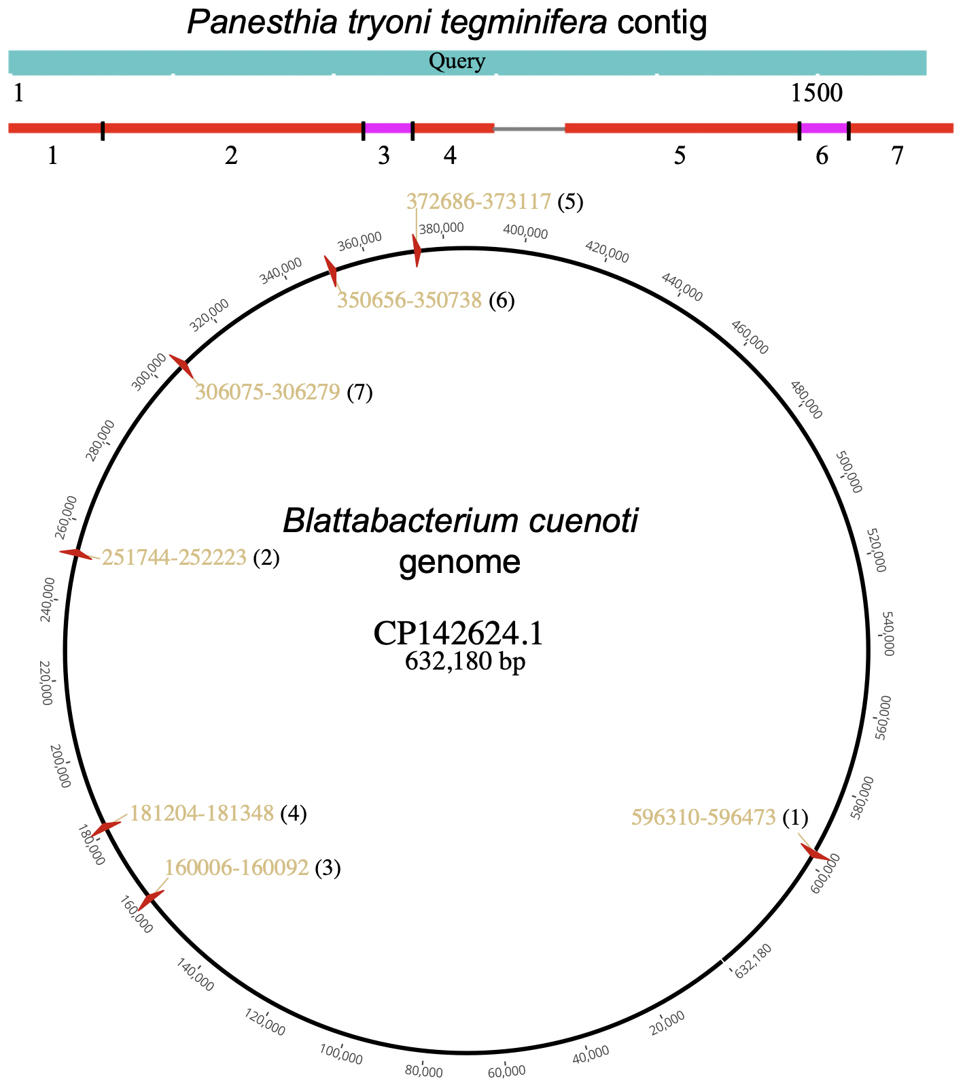
Figure S3. Example of a chimeric HGT insertion in the Panesthia tryoni tegminifera genome. The P. t. tegminifera contig, displayed at the top, is divided into seven segments of different origin, and the circular Blattabacterium cuenoti genome (CP142624.1), displayed at the bottom, indicates the source of these insertions. Numbers below the insertions indicate the corresponding positions in the cockroach and Blattabacterium cuenoti genomes (with yellow labels marking specific coordinates).

Figure X. It would be good to include a screenshot of an raw sequence alignment against an insert, showing that the insert sits with many long read sequences. If there is a bam file, this would just be opnieng it in IGV and taking a screenshot.

Table S1. Blattodea and Blattbacterium genomes details.
Species | Genome ID | Source | Species-specific Blattabacterium genome
Panesthia lata | M1 | This study | Unavailable
Panesthia sloanei | Z1 | This study | Unavailable
Macropanesthia lithgowae | Z4 | This study | GCA_038291465.1
Panesthia tryoni tryoni | Z5 | This study | GCA_038282645.1
Parapanesthia gigantea | Z010 | This study | GCA_038286975.1
Panesthia tryoni tegminifera | Z011 | This study | GCA_038282645.1
Panesthia tryoni tryoni (Eungella) | Z012 | This study | GCA_038280235.1
Neogeoscapheus dahmsi | Z014 | This study | GCA_038260915.1
Panesthia cribrata | T507 | Ewart et al. (2024) | Unavailable
Neogeoscapheus hanni | 4Nhan | Ewart et al. (2024) | GCA_038295885.1
Geoscapheus dilatatus | 8Gdila | Ewart et al. (2024) | GCA_038272405.1
Diploptera punctata | GenBank accession: GCA_030220185.1 | GenBank | CP049785.1
Periplaneta americana v1 | GenBank accession: GCA_025594305.2 | GenBank | CP001429.2
Periplaneta americana v2 | IBG_00622 | InsectBase 2.0 | CP001429.2
Periplaneta americana v3 | CNA0019281 | China National GeneBank Sequence Archive (CNSA) | CP001429.2
Periplaneta americana v4 | GenBank accession: PRJNA1098420 | Re-assembled PacBio data from GenBank | CP001429.2
Blattella germanica v1 | IBG_00115 | InsectBase 2.0 | CP001487.1
Blattella germanica v2 | GenBank accession: GCA_000762945.2 | GenBank | CP001487.1
Zootermopsis nevadensis v1 | IBG_00814 | InsectBase 2.0 | Unavailable
Zootermopsis nevadensis v2 | 20230531.contig | This study (suppplied by co-author, K. Maekawa) | Unavailable
Coptotermes formosanus | IBG_00204 | InsectBase 2.0 | Unavailable
Cryptotermes secundus | IBG_00218 | InsectBase 2.0 | Unavailable
Reticulitermes lucifugus | IBG_01145 | InsectBase 2.0 | Unavailable
Blattabacterium cuenoti | GenBank accession: GCA_014251515.1 | GenBank | NA
Blattabacterium cuenoti | GenBank accession: GCA_014252235.1 | GenBank | NA
Blattabacterium cuenoti | GenBank accession: GCA_014251675.1 | GenBank | NA
Blattabacterium cuenoti | GenBank accession: GCA_014251735.1 | GenBank | NA
Blattabacterium cuenoti | GenBank accession: GCA_014251355.1 | GenBank | NA
Blattabacterium cuenoti | GenBank accession: GCA_014251635.1 | GenBank | NA
Blattabacterium cuenoti | GenBank accession: GCA_014251575.1 | GenBank | NA
Blattabacterium cuenoti | GenBank accession: GCA_014251255.1 | GenBank | NA
Blattabacterium cuenoti | GenBank accession: GCA_014252015.1 | GenBank | NA
Blattabacterium cuenoti | GenBank accession: GCA_014252255.1 | GenBank | NA
Blattabacterium cuenoti | GenBank accession: GCA_014251995.1 | GenBank | NA
Blattabacterium cuenoti | GenBank accession: GCA_014251795.1 | GenBank | NA
Blattabacterium cuenoti | GenBank accession: GCA_014251815.1 | GenBank | NA
Blattabacterium cuenoti | GenBank accession: GCA_014252055.1 | GenBank | NA
Blattabacterium cuenoti | GenBank accession: GCA_014251275.1 | GenBank | NA
Blattabacterium cuenoti | GenBank accession: GCA_014252315.1 | GenBank | NA
Blattabacterium cuenoti | GenBank accession: GCA_014252415.1 | GenBank | NA
Blattabacterium cuenoti | GenBank accession: GCA_014252375.1 | GenBank | NA
Blattabacterium cuenoti | GenBank accession: GCA_014251775.1 | GenBank | NA
Blattabacterium cuenoti | GenBank accession: GCA_014251315.1 | GenBank | NA
Blattabacterium cuenoti | GenBank accession: GCA_014252435.1 | GenBank | NA
Blattabacterium cuenoti | GenBank accession: GCA_014252275.1 | GenBank | NA
Blattabacterium cuenoti | GenBank accession: GCA_014252515.1 | GenBank | NA
Blattabacterium cuenoti | GenBank accession: GCA_014252115.1 | GenBank | NA
Blattabacterium cuenoti | GenBank accession: GCA_014251335.1 | GenBank | NA
Blattabacterium cuenoti | GenBank accession: GCA_014251235.1 | GenBank | NA
Blattabacterium cuenoti | GenBank accession: GCA_014251375.1 | GenBank | NA
Blattabacterium cuenoti | GenBank accession: GCA_014252455.1 | GenBank | NA
Blattabacterium cuenoti | GenBank accession: GCA_014251615.1 | GenBank | NA
Blattabacterium cuenoti | GenBank accession: GCA_014252295.1 | GenBank | NA
Blattabacterium cuenoti | GenBank accession: GCA_014251295.1 | GenBank | NA
Blattabacterium cuenoti | GenBank accession: GCA_014251715.1 | GenBank | NA
Blattabacterium cuenoti | GenBank accession: GCA_014252395.1 | GenBank | NA
Blattabacterium cuenoti | GenBank accession: GCA_014251535.1 | GenBank | NA
Blattabacterium cuenoti | GenBank accession: GCA_014252075.1 | GenBank | NA
Blattabacterium cuenoti | GenBank accession: GCA_014251695.1 | GenBank | NA
Blattabacterium cuenoti | GenBank accession: GCA_014251655.1 | GenBank | NA
Blattabacterium cuenoti | GenBank accession: GCA_014251755.1 | GenBank | NA
Blattabacterium cuenoti | GenBank accession: GCA_014252355.1 | GenBank | NA
Blattabacterium cuenoti | GenBank accession: GCA_014252035.1 | GenBank | NA
Blattabacterium cuenoti | GenBank accession: GCA_014252095.1 | GenBank | NA
Blattabacterium cuenoti | GenBank accession: GCA_014251595.1 | GenBank | NA
Blattabacterium cuenoti | GenBank accession: GCA_014252335.1 | GenBank | NA
Blattabacterium cuenoti | GenBank accession: GCA_014251955.1 | GenBank | NA
Blattabacterium cuenoti | GenBank accession: GCA_014251555.1 | GenBank | NA
Blattabacterium cuenoti | GenBank accession: GCA_014251975.1 | GenBank | NA
Blattabacterium cuenoti | GenBank accession: GCA_038255535.1 | GenBank | NA
Blattabacterium cuenoti | GenBank accession: GCA_038257325.1 | GenBank | NA
Blattabacterium cuenoti | GenBank accession: GCA_038259185.1 | GenBank | NA
Blattabacterium cuenoti | GenBank accession: GCA_038260915.1 | GenBank | NA
Blattabacterium cuenoti | GenBank accession: GCA_038261755.1 | GenBank | NA
Blattabacterium cuenoti | GenBank accession: GCA_038262975.1 | GenBank | NA
Blattabacterium cuenoti | GenBank accession: GCA_038264265.1 | GenBank | NA
Blattabacterium cuenoti | GenBank accession: GCA_038265535.1 | GenBank | NA
Blattabacterium cuenoti | GenBank accession: GCA_038266905.1 | GenBank | NA
Blattabacterium cuenoti | GenBank accession: GCA_038268195.1 | GenBank | NA
Blattabacterium cuenoti | GenBank accession: GCA_038269515.1 | GenBank | NA
Blattabacterium cuenoti | GenBank accession: GCA_038270875.1 | GenBank | NA
Blattabacterium cuenoti | GenBank accession: GCA_038272405.1 | GenBank | NA
Blattabacterium cuenoti | GenBank accession: GCA_038273955.1 | GenBank | NA
Blattabacterium cuenoti | GenBank accession: GCA_038276025.1 | GenBank | NA
Blattabacterium cuenoti | GenBank accession: GCA_038278115.1 | GenBank | NA
Blattabacterium cuenoti | GenBank accession: GCA_038280235.1 | GenBank | NA
Blattabacterium cuenoti | GenBank accession: GCA_038282645.1 | GenBank | NA
Blattabacterium cuenoti | GenBank accession: GCA_038284835.1 | GenBank | NA
Blattabacterium cuenoti | GenBank accession: GCA_038286975.1 | GenBank | NA
Blattabacterium cuenoti | GenBank accession: GCA_038289285.1 | GenBank | NA
Blattabacterium cuenoti | GenBank accession: GCA_038291465.1 | GenBank | NA
Blattabacterium cuenoti | GenBank accession: GCA_038293255.1 | GenBank | NA
Blattabacterium cuenoti | GenBank accession: GCA_038294535.1 | GenBank | NA
Blattabacterium cuenoti | GenBank accession: GCA_038295885.1 | GenBank | NA
Blattabacterium cuenoti | GenBank accession: CP005488.1 | GenBank | NA
Blattabacterium cuenoti | GenBank accession: AP012548.1 | GenBank | NA
Blattabacterium cuenoti | GenBank accession: CP003000.1 | GenBank | NA
Blattabacterium cuenoti | GenBank accession: CP001487.1 | GenBank | NA
Blattabacterium cuenoti | GenBank accession: CP001429.2 | GenBank | NA
Blattabacterium cuenoti | GenBank accession: CP003015.1 | GenBank | NA

Table S2. QC of newly assembled cockroach genomes.
Sample name | Species | Basecalling mode | Length (Gb) | N50 (Mb) | Complete BUSCOs (%) | Fragmented BUSCOs (%)
M1 | Panesthia lata | simplex, with sup | 1.77 | 1.14 | 97.6 | 1.7
Z1 | Panesthia sloanei | simplex, with sup | 1.82 | 1.67 | 98.7 | 0.6
Z4 | Macropanesthia lithgowae | simplex, with sup | 1.82 | 1.44 | 98 | 1.1
Z5 | Panesthia tryoni tryoni | simplex, with sup | 1.72 | 0.63 | 95.2 | 1.9
Z010 | Parapanesthia gigantea | duplex, with sup | 1.85 | 1.04 | 98.2 | 0.7
Z011 | Panesthia tryoni tegminifera | duplex, with sup | 1.84 | 1.19 | 98.9 | 0.4
Z012 | Panesthia tryoni tryoni (Eungella) | duplex, with sup | 1.86 | 0.86 | 97.9 | 1
Z014 | Neogeoscapheus dahmsi | duplex, with sup | 1.9 | 5.33 | 99.5 | 0.1

